NAME : Pushti Shah SAP ID: 60019210097
ROLL NO: B074 SUB: Network Security
EXP 4
Configuration of SSL/SSH
in a Secure Client-Server Model

1. Aim of the Lab
In this lab, you will learn how to secure communication in a network using cryptographic techniques.

By the end of this experiment, you will be able to:
- Secure remote login using SSH key-based authentication
- Secure web communication using SSL/TLS
- Capture and analyze network packets
- Understand the difference between encrypted and unencrypted traffic

2. Environment Setup
To create a safe and isolated network, we use Vagrant. Vagrant allows us to run two virtual machines that can talk to each other like real computers.

Virtual Machines Used
Machine | Hostname | IP Address
Server | secure-server | 192.168.56.10
Client | client-node | 192.168.56.11

Step 1: Create the Vagrant Environment
- Inside your VsCode Editor, create a file named Vagrantfile
- Paste the following code inside the file:

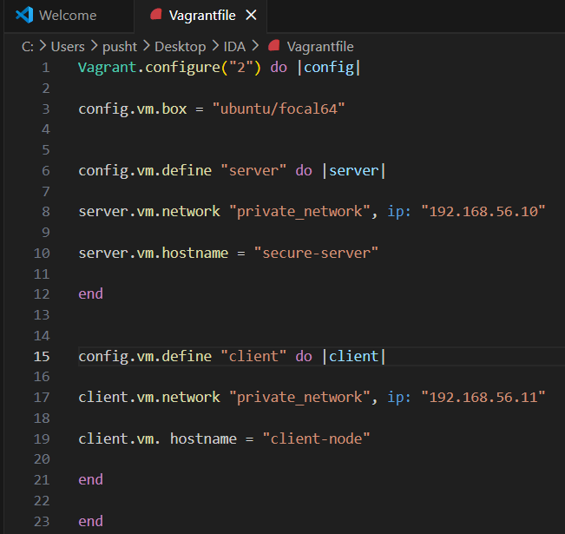

Step 2: Setting Up Terminals
- Create Two Terminals
- Rename them as Client and Server

Step 2: Starting Virtual Machines
In, Client Terminal
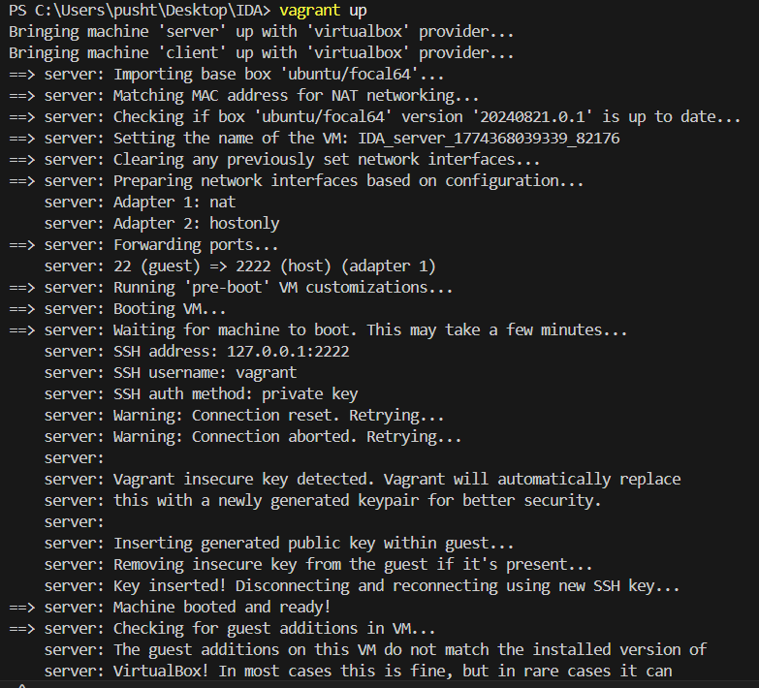

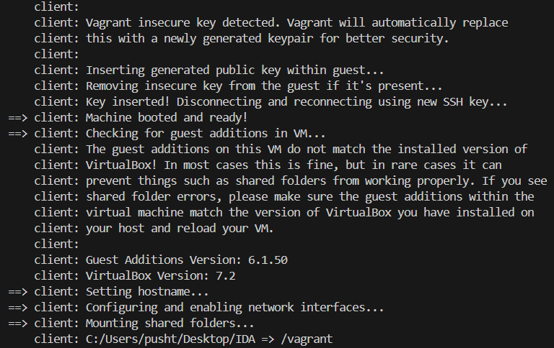
Part A: Securing Remote Access Using SSH

3. Part A: SSH Key-Based Authentication

Why SSH Keys?
SSH key authentication is more secure than passwords. The private key never leaves your machine, so credentials cannot be captured over the network.

- Password login can be cracked using brute force
- SSH keys are more secure
- Passwords are never sent over the network

Step 1: Generate SSH Keys (Client Machine)
- Login to the client machine:
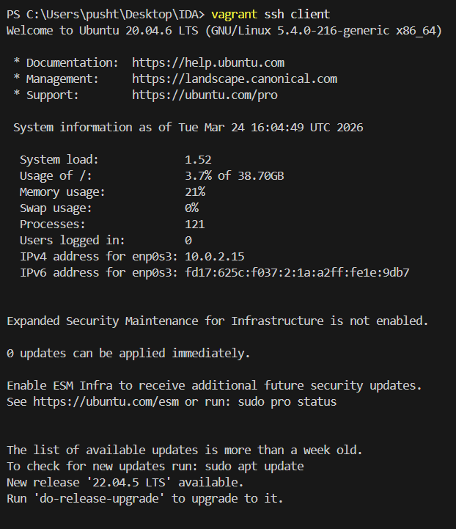

- Generate an RSA key pair
& Press Enter for all questions:

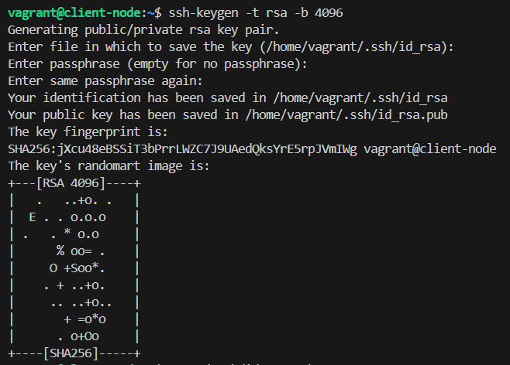

- Display the public key:

- Copy the the public key to your clipboard

Step 2: Add Public Key to Server
- Open another terminal
- Login to server:

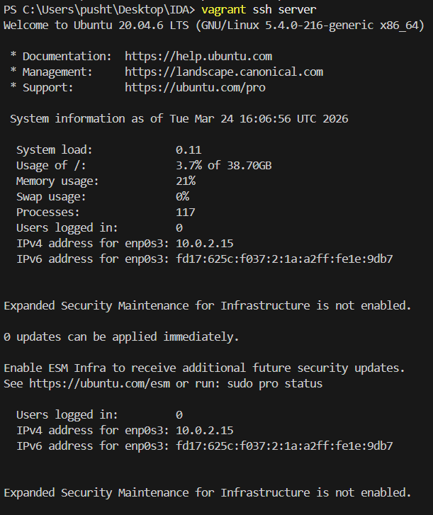

- Open authorized keys file:
- Paste the copied public key on a new line
- Save and exit (CTRL + O, Enter, CTRL + X)

Step 3: Test SSH Login
From the client machine, run:
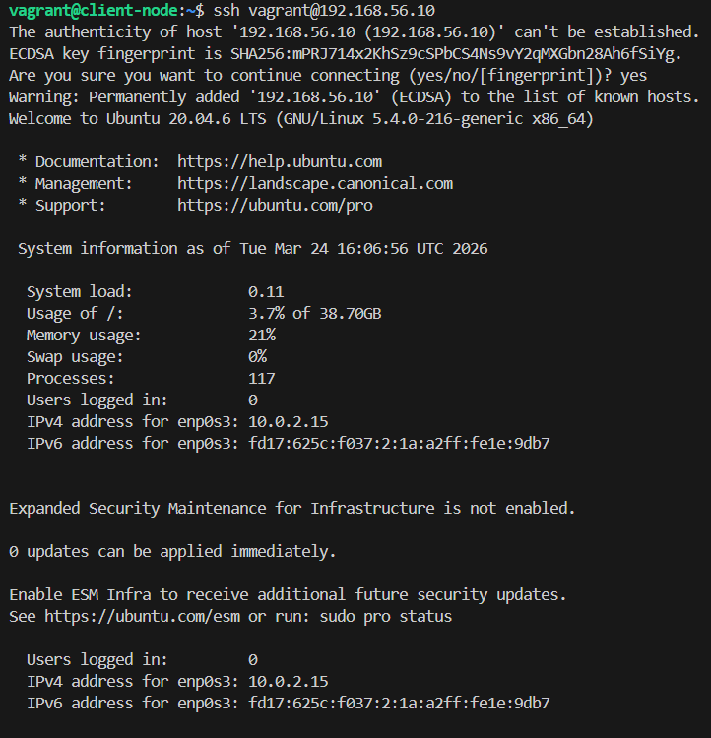

✅ SUCCESS: You should log in without entering any password. This confirms SSH key-based authentication is working correctly.

Part B: Securing Web Traffic Using SSL/TLS

4. Part B: SSL/TLS Web Encryption

Why SSL/TLS?
HTTP transmits data in plain text — anyone on the network can read it. HTTPS uses TLS certificates to encrypt all data in transit.

- HTTP sends data in plain text
- Anyone can intercept and read the data
- HTTPS encrypts data using digital certificates

Step 1: Install Apache and Enable SSL (Server)
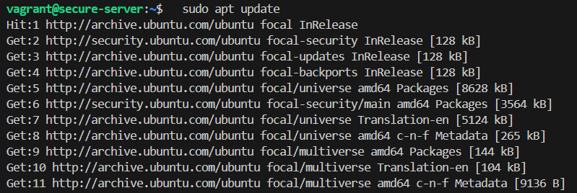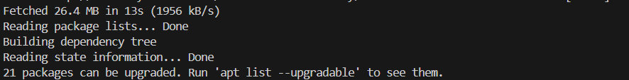

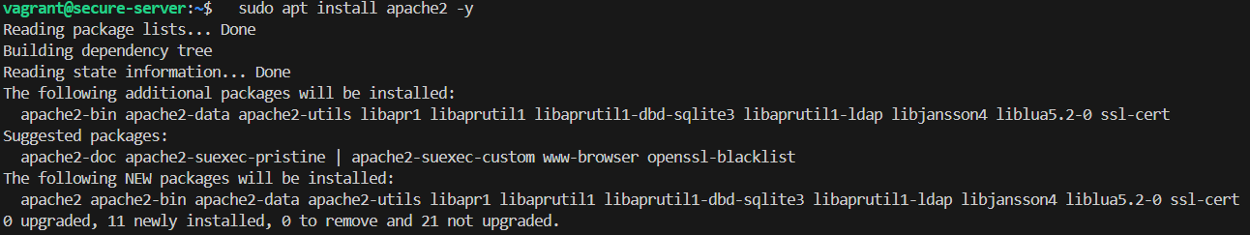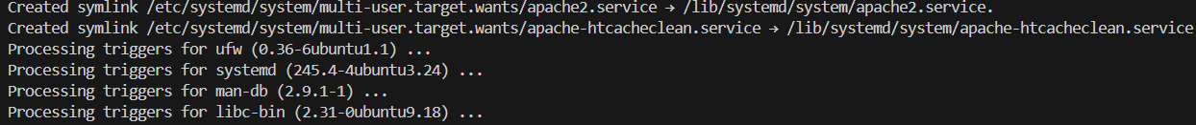

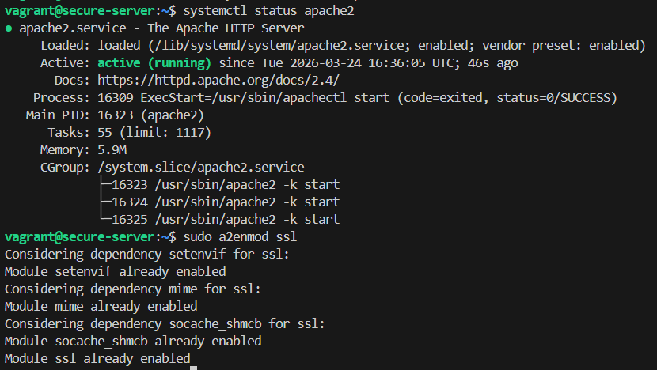

Step 2: Create a Self-Signed Certificate
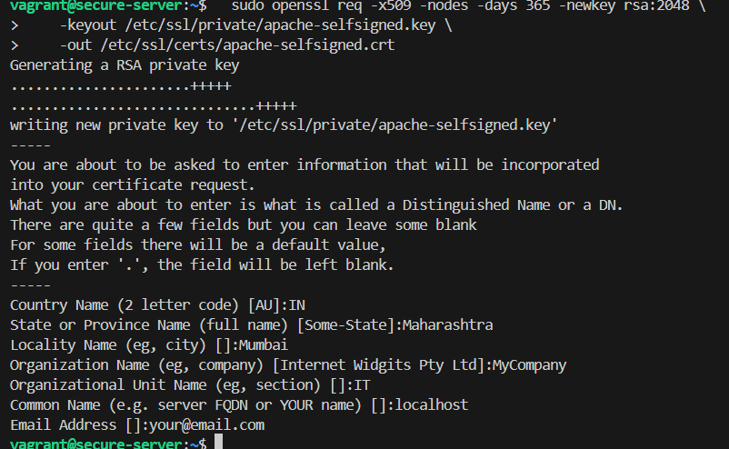

Note: Fill in the certificate details when prompted, or simply press Enter to accept defaults. This certificate is valid for lab/testing purposes only.

Step 3: Configure Apache to Use SSL
- Open SSL configuration file:

- Update the following lines:
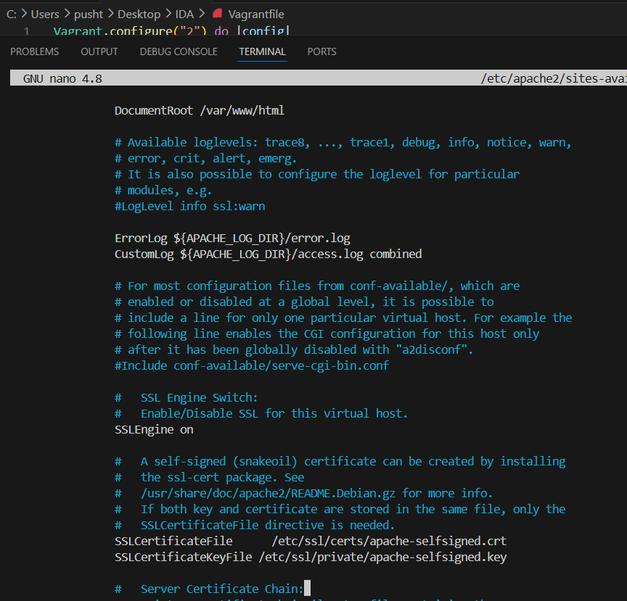

- Enable SSL site and restart Apache:

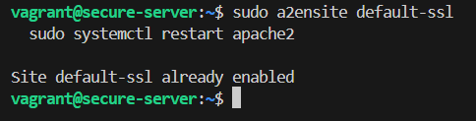
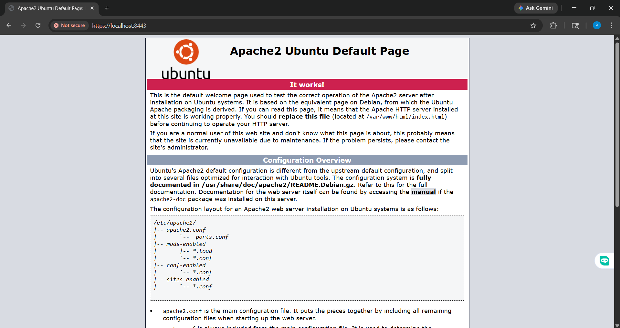

Part C: Packet Analysis Using tcpdump and Wireshark

5. Part C: Packet Analysis
We now verify whether the data being transmitted is encrypted or readable to an observer on the network.

Step 1: Capture HTTP Traffic (Port 80)
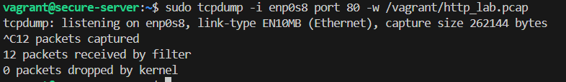On the Client:
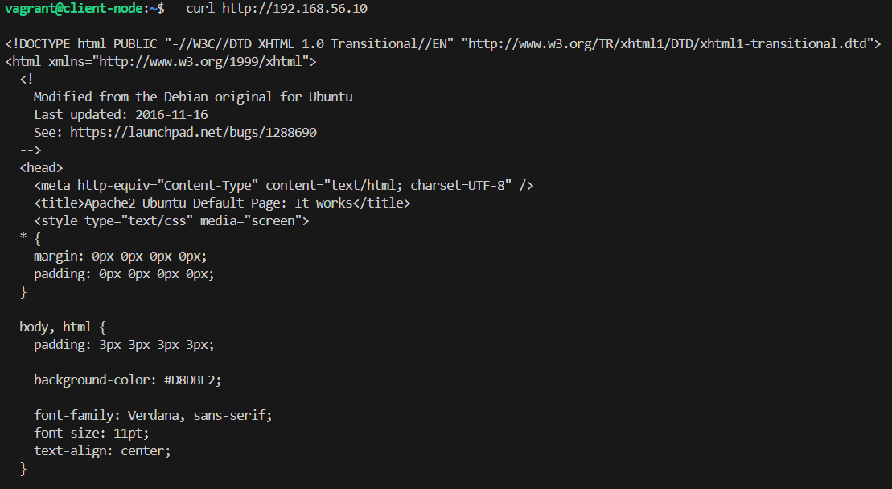

Step 2: Capture HTTPS Traffic (Port 443)
On the Server:
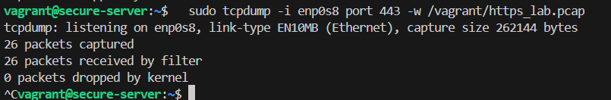On the Client:
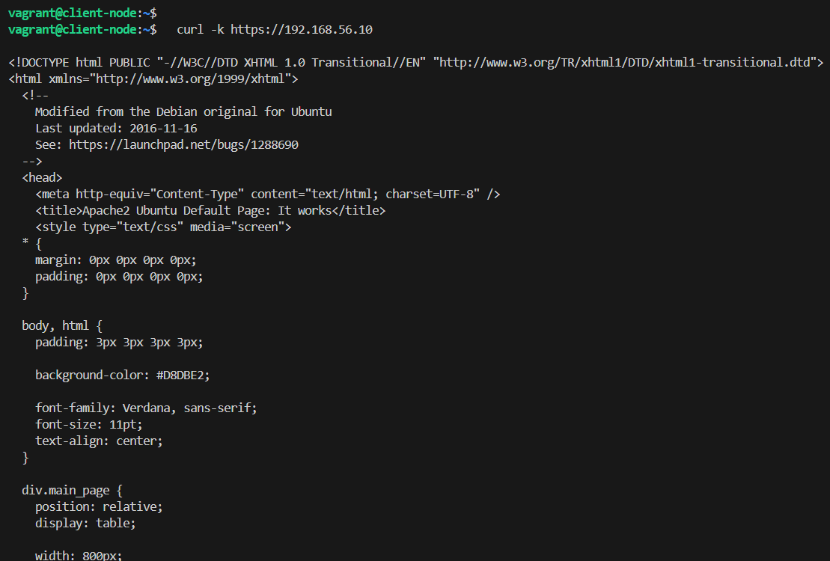

Step 3: Analyze in Wireshark (Host Machine)
- Locate Package Capture File
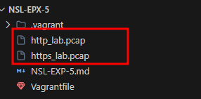
- Right click on any file ===> Reveal in File Explorer
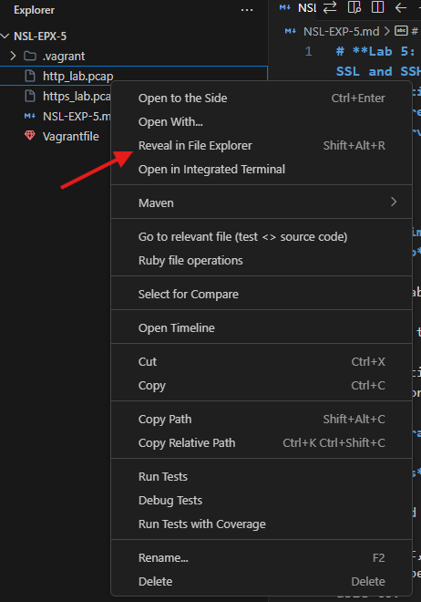
- Open Both files in Wireshark
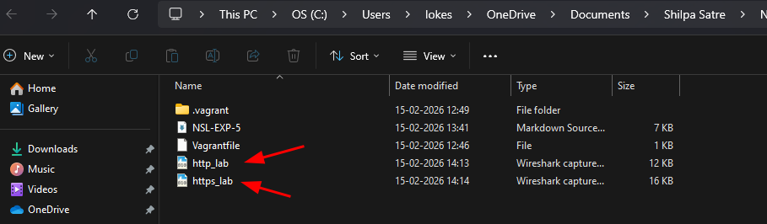
HTTP Capture (Port 80) | HTTPS Capture (Port 443)
Filter: http  You will see:  GET request  HTTP Headers  Full HTML content  ❌ Data is FULLY READABLE | Filter: tls  You will see:  TLS Client Hello  TLS Server Hello  Encrypted Application Data  ✅ Data is ENCRYPTED and UNREADABLE

http: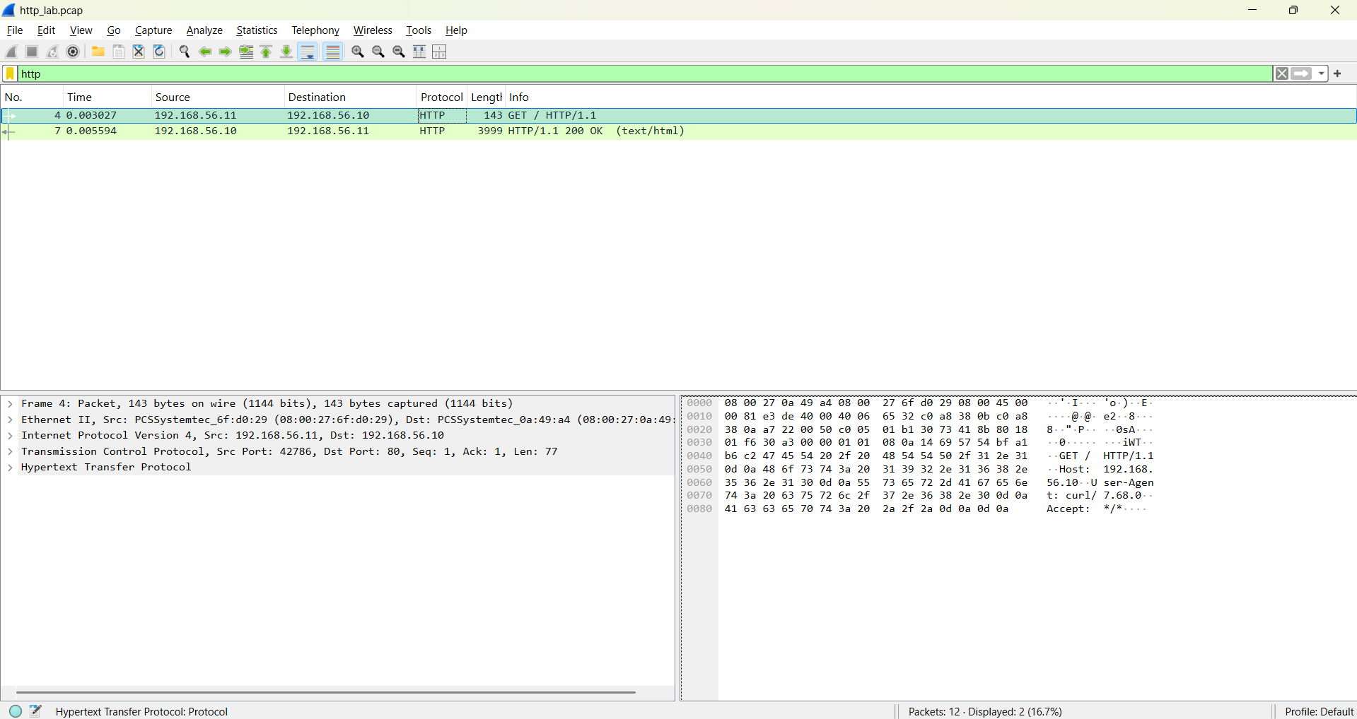

https:
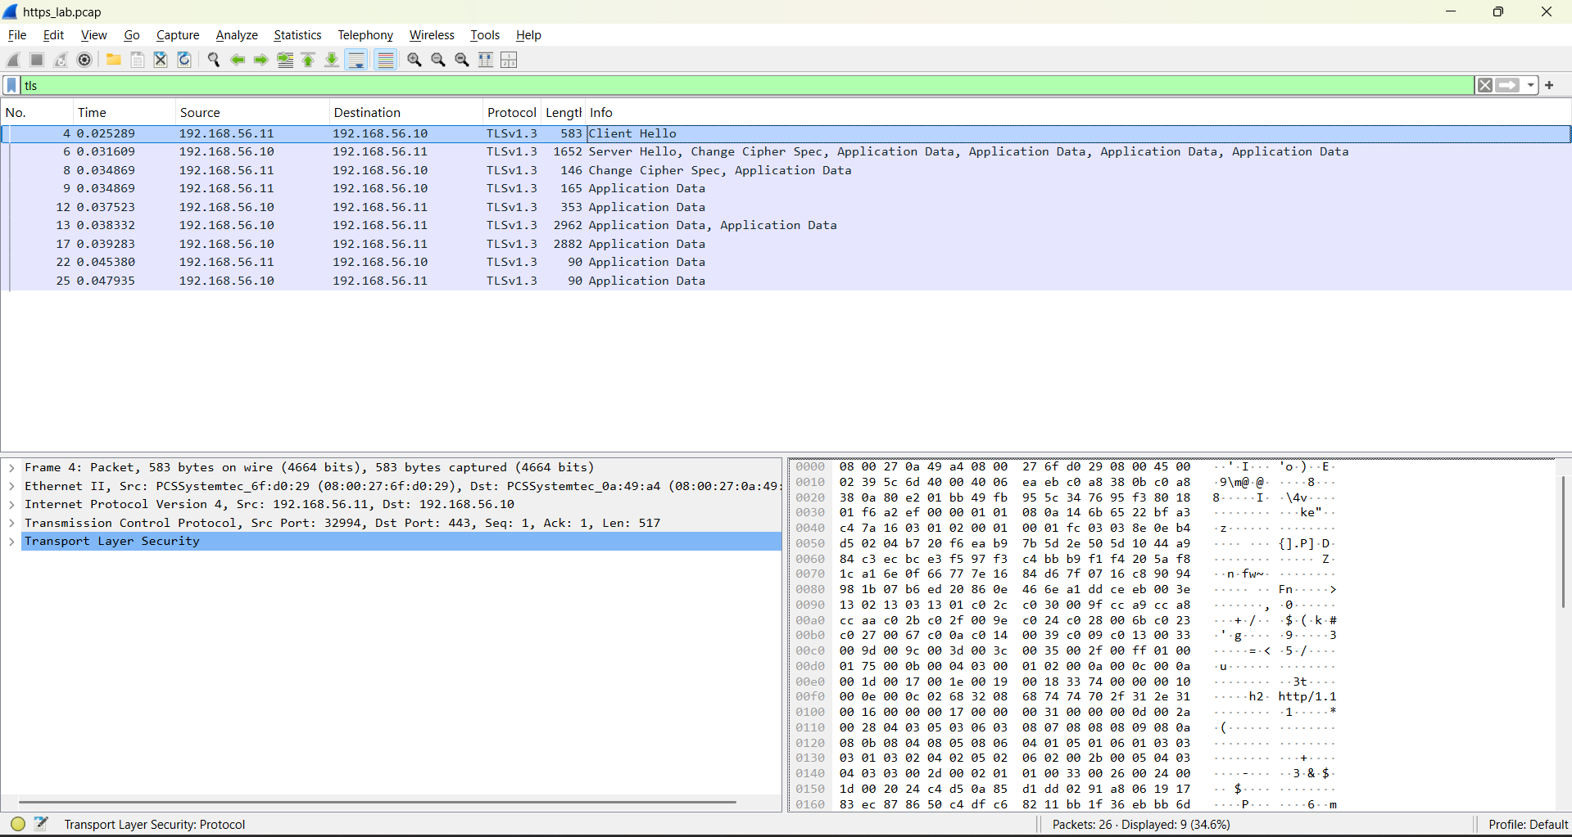

6. Result and Comparison
The table below summarizes the key differences observed during the experiment:
Feature | HTTP | HTTPS
Protocol | HTTP | TLS
Data Visibility | Plain text | Encrypted
Security | Not secure | Secure
Authentication | None | Server certificate
Data Protection | ❌ No | ✅ Yes

7. Conclusion
In this lab, we successfully demonstrated the practical implementation of secure communication protocols in a networked environment:

SSH Key-Based Access: Eliminated password-based authentication vulnerabilities by using RSA key pairs for secure remote login.
SSL/TLS Web Encryption: Configured Apache with a self-signed certificate to serve encrypted HTTPS traffic.
Packet Capture & Verification: Used tcpdump and Wireshark to confirm that HTTP data is visible as plain text, while HTTPS traffic is fully encrypted.
Security Takeaway: Implementing SSL/TLS and SSH keys are fundamental steps toward building a secure client-server architecture.

